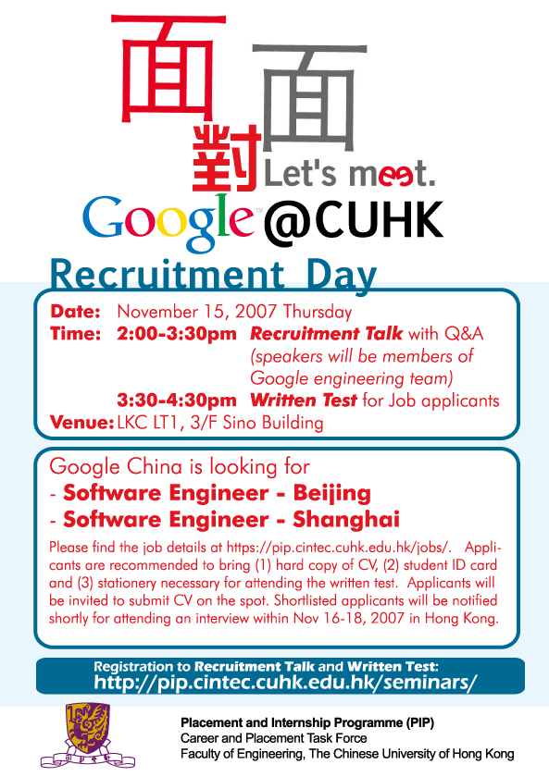
Google will do recruiting events in CUHK on Nov 15th, please kindly bring your paper resume with you when attending Tech Talk.

Following is the recruiting agenda:
Nov 15th
Google Tech Talk | 2:00pm-2:50pm | Li Koon Chun Hall, LT1
- Google Engineer Interaction Session  - Q & A with Google Gift | 2:50pm-3:20pm | Li Koon Chun Hall, LT1
Break | 3:20pm-3:30pm
Written Test | 3:30pm-4:20pm | Li Koon Chun Hall, LT1
Nov 15-16
Interview Notice + Submission of online resume
Nov 16-18
Interview

Job Description

Software Engineer - New Grad – Beijing
Software Engineer - New Grad – Shanghai
Positions are available in Beijing and Shanghai, China.
Are you:
Interested in helping to mentor a great team of smart, passionate engineers?
Interested in helping to develop both great products for China and the world such as mobile, multimedia, local/map products and community products?
Interested in moving to the fastest growing and soon-to-be-largest Internet market in the world?
Interested in helping enhance web search that will be used by 137 million Internet users in China?
Interested in working with a team of top software talents in a fast-paced and engineering-driven environment in China?
The world-class engineering team in Google China is looking for software engineers with superb design and implementation skills and considerable depth and breadth in the areas of high-performance distributed systems, operating systems, data mining, information retrieval, machine learning, and/or related areas. If you have a proven track record in cutting-edge research and/or large-scale systems development in these areas, we have plenty of challenging projects for you.

Consider the kinds of problems we tackle at Google:
- Natural language processing
- Artificial intelligence
- Distributed computing
- Large-scale system design
- Machine learning
- Data compression
- UI
- Information retrieval
The list goes on – and with the help of clever, curious, problem-solving engineers, the work, and the fun, goes on too.
Requirements:
- BS/MS/PhD in Computer Science or related technical field.
- Experience with Unix/Linux or Windows environments, C++, Java, distributed systems, machine learning, information retrieval, TCP/IP and network programming and/or developing large software systems a plus.
- Knowledge of Perl, Python, or other scripting languages a plus.

